

**Loudoun County Public Schools**

Allergy Action Plan

Location of

Auto-injector_______________________

Name:______________________________________________D.O.B: ___/___/____

Allergy to:______________________________________________________________

Weight:_______lbs. Asthma: ___ Yes (higher risk for a severe reaction) ___ No Grade _________

Extremely reactive to the following food:____________________________________________

THEREFORE:

**___**If checked, give epinephrine immediately for ANY symptoms if the allergen was *likely* eaten.

___If checked, give epinephrine immediately if the allergen was *definitely* eaten, even if no symptoms are noted.

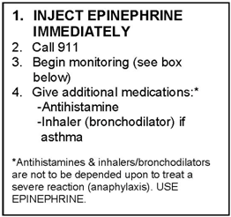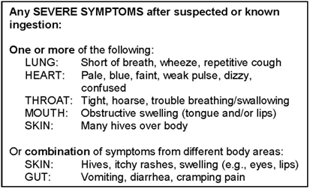





**1. GIVE ANTHISTAMINE**

**2. Stay with student: alert**

**healthcare professionals first, then**

**parent**

**3. If symptoms progress (see**

**above), USE EPINEPHRINE**

**4. Begin monitoring**

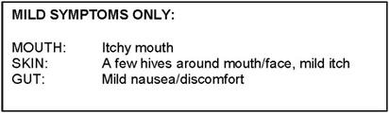

**Medications/Doses**

Epinephrine dose: ________________________________________________________

Antihistamine (brand and dose): ______________________________________________________

A second dose of epinephrine can be given 5 minutes or more after the first if symptoms persist or recur.

**It is my professional opinion that this student SHOULD/SHOULD NOT carry his/her epinephrine auto-injector.**

____________________________________ ________ ___________________________________ ________

**Parent/Guardian Signature Date Physician/Healthcare Provider Signature Date**

Parent signature gives permission for principal’s designee to follow this plan, administer prescribed medicine, and contact physician, if necessary.

**__________________________________ ______________________ __________________**

**Physician’s Printed Name /Address Fax Number Phone Number**

2014Adapted with permission for FAAN’s 2011 Food Allergy Action Plan **(**[**www.foodallergy.org**](http://www.foodallergy.org)**)** Page 1/4

**Loudoun County Public Schools**

Allergy Action Plan

**Information about Epinephrine Procedures:**

* Please notify the teacher/sponsor about your child’s allergy when your child will be staying for any school-sponsored after school activities.
* The clinic is closed after dismissal and the nurse/health clinic specialist is not in the building. It is strongly suggested that middle and high schools students carry their own auto-injector for quick access to epinephrine.

____________________________________________________ ___________

**Parent/Guardian Signature Required Date**

**Parent/Student Agreement for Permission to Self-Administer and/or Carry Epinephrine**

**PARENT:**

* I give my consent for my child to self-administer and/or carry his/her auto-injector of epinephrine.
* I understand that the school board or its employees cannot be held responsible for negative outcomes resulting from self-administration of epinephrine.
* This permission to self-administer and/or possess epinephrine may be revoked by the principal if it is determined that your child is not safely and effectively self-administering the medication.
* A new Physician Order/Care Plan for Severe Allergy and Parent/Student Agreement for Permission to Carry Epinephrine must be submitted each school year.

__________________________________________________ ____________

**Parent/Guardian’s Signature Required Date**

**STUDENT:**

* If I am to self-administer, I have demonstrated the correct use of an auto-injector of epinephrine to the school nurse/health clinic specialist.
* I agree never to share my epinephrine with another person or use it in an unsafe manner.
* I agree that if I inject epinephrine, I will immediately report to the school nurse/health clinic specialist or another appropriate adult if the nurse/health clinic specialist is not available so that EMS is called.

___________________________________________________ ____________

**Student’s Signature Date**

2014 Page 2/4

**Monitoring**

***Stay with student; alert healthcare professionals and then the parent***. Tell rescue squad epinephrine was given; request an ambulance with epinephrine. Note time when epinephrine was administered. For a severe reaction, consider keeping student lying on back with legs raised. Treat student even if parents cannot be reached. **DO NOT MOVE STUDENT.**

**3-Step Easy Follow to Instructions: ** 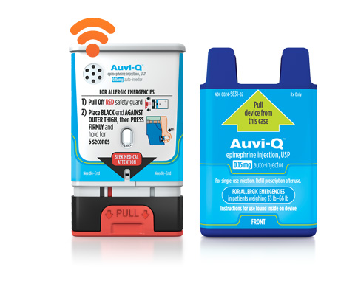

1. **Prepare** the Auto-Injector Injection

2. **Administer** the Auto-Injector

3. **Finalize** the Injection Process

**Contacts**

Doctor:_________________________________________________ Phone (_____)______-________

Parents/Guardian:________________________________________ Phone(_____)______-_________

**Other Emergency Contacts**

Name/Relationship:______________________________________ Phone(____)______-_________

Name/Relationship:______________________________________ Phone(____)______-_________

**Number of epinephrine auto-injectors received: 1____ 2____3____4____ Expiration Date:__________**

**Signature of clinic staff/Date:____________________________________________________**

**Number of epinephrine auto-injectors returned: 1____2_____3____ 4____**

**Signature of Parent/Date:____________________________________________________**

2014Adapted with permission for FAAN’s 2011 Food Allergy Action Plan ([www.foodallergy.org](http://www.foodallergy.org)) Page 3/4

 **Loudoun County Public Schools**

**Severe Allergy Individual Health Care Plan (IHCP)**

**Student’s Name________________________________________ Grade_______**

**Teacher’s Name_________________________ Lunch Time________________**

**Known Allergen________________________________________ Symptoms_________________**

**Date of last anaphylactic reaction?__________________ Was epinephrine given? ___Yes ___No**

**Classroom**

* **Any food given to student must be approved by parent.**
* **LCPS staff will not read labels.**
* Alternative food will be provided by parent/guardian.
* Parent/guardian should be advised of any planned parties.
* Classroom projects/parties involving food should be reviewed by the parent and the teaching staff in a reasonable amount of time.

**Bus**

* Transportation will be alerted to student’s allergy.
* Student has a physician’s order to carry epinephrine on bus. ____YES ____No

**Field Trip Procedures**

* Parent should be notified early in the planning process to address any risk of allergen exposure.
* Epinephrine should accompany student during any off-campus activity.
* The elementary student should remain with the teacher during the entire field trip.
* Middle school/high school student should remain with the teacher during the entire field trip. ___Yes __No

**Cafeteria**

* Cafeteria manager and attendant will be alerted to the student’s allergy.
* All cafeteria tables are cleaned per cafeteria guidelines.
* Cafeteria menu is available online and monthly from school newsletter.
* If the student is purchasing food from the LCPS menu, **parents must approve food choices.**
* Complete list of menu ingredients can be accessed through the LCPS Food Services website.

**CHOOSE 1:**

**________ There are NO restrictions where student may sit in the cafeteria.**

**Or,**

**________**Student will sit at a specified allergy table in the cafeteria.

**________**Student will sit with their class at a specified location.

_____________________________________________ ___________

Parent’s Signature Date

_____________________________________________ ___________

Clinic Staff/RN Signature Date

2014 Page 4/4